**Flight delay prediction**

1 Introduction

Over the last few decades, air transport is increasing popularity because of speed and comfort which eventually increase the traffic in the airspace. With the great increase in air traffic comes a large increase in the demand for airport capacity. However, airspace and airport capacity cannot keep increasing at a rate necessary to match the rising demand. When an airport's capacity is reduced during “peak hours", the demand for an airport's resources exceeds the capacity that the airport can afford. Many major airports around the world have significant delay problems because of an imbalance between capacity and demand. Flight delays are obviously frustrating to air travellers and costing billions to airlines and travellers. The study found that airlines with high rates of delay also have higher operating costs overall. The direct cost to airlines included increased expenses for crew, fuel, and maintenance, among others. Flight delays are complex to explain and subdivided into many types of delays like weather delays, Air Carrier delay, security delay, National Aviation system delay.

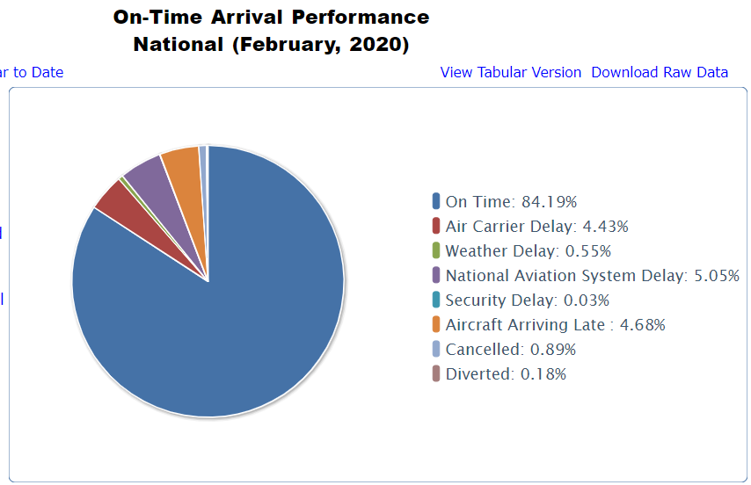

Related Work:

There are several works in the literature that focus on airport delays, air-traffic . Airline operations are highly complicated processes that are intended to regulate expensive, tightly constrained, and interdependent resources, such as the crew, aircraft, airports, and maintenance facilities. Myriads of research have been carried out on aviation planning problems such as delays, but only a few have been performed on the characteristics of airline delays and the prediction of delay statistics. Delays occur when an event takes place later than the time at which it is planned, scheduled, or expected to happen. Delays in departure can occur due to bad weather conditions, seasonal and holiday demands, airline policies, technical issues such as the problems in airport facilities, luggage handling and mechanical apparatus, and accumulation of delays from preceding flights.

The research conducted by Grether and Nagel in 2013 used scaling and simulation software for flight data. They normalized the data, pre-process the data and simulate the results like inbound flights, outgoing flights. They changed local times to UTC(Coordinated Universal Time) for consistency. (*Agent-based Modelling and Simulation of Air Transport Technology*, 2013)

Dieterich Lawson and William Castillo, in their project” Predicting Flight Delays” in 2012 (Lawson & Castillo, 2012), used dataset of flights including several years, which resulted in 135 million of flights. However, work on weather data only obtaining 40% recall. They used algorithms like support vector machines, Naïve Bayes, and Random forest.

In another research article by Nathalie Kuhn and Navaneeth in their project “Application of Machine Learning Algorithms to predict flight delays “used machine Learning algorithms like decision trees, Neural Network and Logistic regression algorithms and concluded that Departure delay is main factor in aircraft delay. They also performed some statistical analysis like average delays of flights and basic summary statistics.(Kuhn and Jamadagni, 2017)

Another report published by Neil and Samir report titled “Predicting flight delays and cancellations using weather as a feature” compared algorithms like Random forest, XGboost(Extreme Gradient), Linear regression, and SVM with AUC(Area Under Curve) 0.81 highest among all algorithms.

References:

* Movva, N. and Menon, S., n.d. *Predicting Flight Delays And Cancellations Using Weather As A Feature*. [online] Available at: <http://cs229.stanford.edu/proj2016/report/MenonMovva-PredictingFlightDelays-report.pdf> [Accessed 12 April 2020].
* Lawson, D. and Castillo, W. Predicting flight delays. Technical report, Computer Science Department, CS 229, Stanford University, Stanford, CA, 2012.
* Kuhn, N. and Jamadagni, N., 2017. Application of Machine Learning Algorithms to Predict Flight Arrival Delays. [online] Available at: <https://pdfs.semanticscholar.org/e7b5/dc454ee3d6b2c40c4b7ea3c0893465b4b72b.pdf?_ga=2.45290660.1417358091.1587150044-1906038309.1578515099> [Accessed 17 April 2020].
* *Agent-based Modelling and Simulation of Air Transport Technology*. (2013). Retrieved from https://www.sciencedirect.com/science/article/pii/S1877050913007175